Entrance

Looks like…
- Waiting at the door to shake Mr. Simoneau’s hand before entering.
- Custom handshakes are encouraged.

Sounds like…
- Quiet conversations with friends and Mr. Simoneau are allowed.

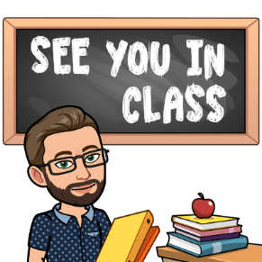
Taking Exit Tickets

Looks like…
- Politely waiting your turn to take an Exit Ticket from the cart by the door.

Sounds like…
- Quiet conversations with friends are allowed.

Seating

Looks like…
- Choosing a seat or place where you can focus and not distract others.

Sounds like…
- Quietly walking to your seat or your place.

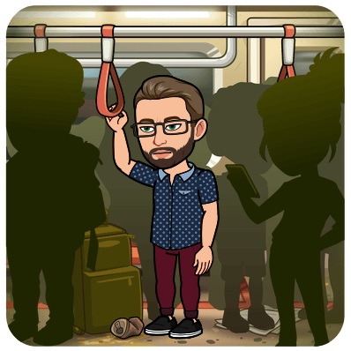
Personal Space

Looks like…
- Keeping your hands, arms, legs, feet, and personal items to yourself at all times.

Sounds like…
- Keeping your voice at an acceptable level for the classroom

Filling Out Exit Tickets

Looks like…
- Getting out your pen/pencil.
- Filling out the Daily Objectives and the Task List.
- Paying attention to the countdown timer to make sure you are on pace

Sounds like…
- Quietly Filling out the Daily Objective and the Task List

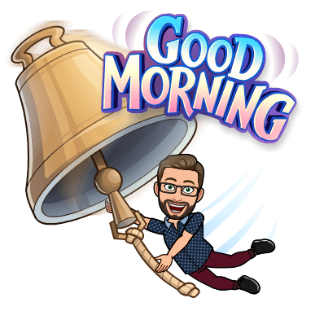
Bell Work

Looks like…
- Getting any additional supplies noted on the board for the Bell Work
- Following any additional instructions noted on the board for the Bell Work.
- Paying attention to the countdown timer to make sure you are on pace

Sounds like…
- Following any additional “Sounds like…” instructions noted on the board.

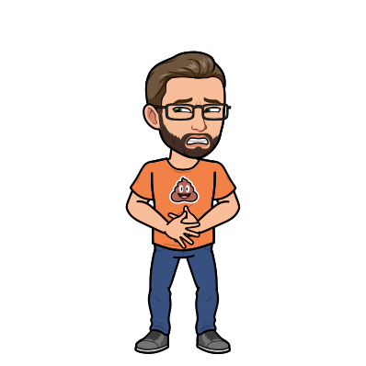
Bathroom Passes

Looks like…
- Leaving the classroom
- Giving the Bathroom pass to the teacher to sign at the end of class.

Sounds like…
- Quietly leaving the classroom
- Quietly reentering the classroom

Pair Share

Looks like…
- Turning to the partner next to you

Sounds like…
- Quietly sharing your wisdom and/or opinion addressing the prompt.

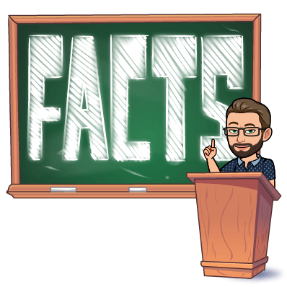
Review / Instructions / Directions

Looks like…
- Turning your bodies to face the front of the class.
- Closing your mouths.
- Looking at the teacher, Smart Board, or the Whiteboard.
- Writing down notes or correcting mistakes.

Sounds like…
- Silently paying attention to what the teacher is saying.

Asking / Answering Questions

Looks like…
- Raising your hand until the teacher calls on you.
- Paying attention as the teacher passes the speaking ball to you.

Sounds like…
- Remaining quiet until the whole class is paying attention to what you have to say.
- Sharing information that is relevant to the topic of conversation.

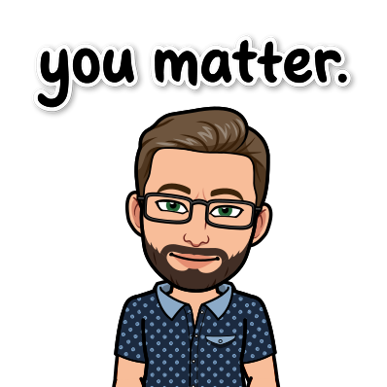
Listening to Other Students

Looks like…
- Turning your bodies to face the person speaking.
- Closing your mouths.
- Looking at the teacher, Smart Board, or the Whiteboard.
- Writing down notes or correcting mistakes.

Sounds like…
- Silently paying attention to what the student is saying.

Class Discussion

Looks like…
- Turning your bodies to face the person speaking.
- Respecting the opinions, ideas, and freedoms of others.

Sounds like…
- Silently paying attention to what the student is saying.
- Remaining quiet until the whole class is paying attention to what you have to say.
- Sharing information that is relevant to the topic of conversation.

Group Work

Looks like…
- Facing the group that you are working with.
- Understand the purpose of the activity.
- Identify the strengths of the team.
- Working together.
- Paying attention to the countdown timer to make sure you are on pace

Sounds like…
- Communicating with the team what is being asked of the group.
- Defining the goals of the activity: Discuss with the team what they would like to present.
- Making sure that everyone knows their roles and what is expected of them.
- Engaging in relevant conversation about the work .

Group Presentations

Looks like…
- Turning your bodies to face the group speaking.
- Respecting the opinions, ideas, and freedoms of others.
- Standing at the front of the class when presenting.
- Sharing the presentation responsibilities with the whole group.

Sounds like…
- Silently paying attention to what the student is saying.
- Remaining quiet until the whole class is paying attention to what you have to say.
- Sharing information that is relevant to the topic of conversation.
- Sharing the presentation responsibilities with the whole group.

Individual Work / Independent Reading

Looks like…
- Working in your own space on the task at hand.
- Paying attention to the countdown timer to make sure you are on pace.
- Independently reading when you have accomplished the individual work

Sounds like…
- Silently working on the task at hand

Individual Test Taking

Looks like…
- Keeping your eyes on your own work
- Using only the material and media that the teacher provided to complete the test.
- Independently reading when you have finished your test.

Sounds like…
- Silently completing the test.

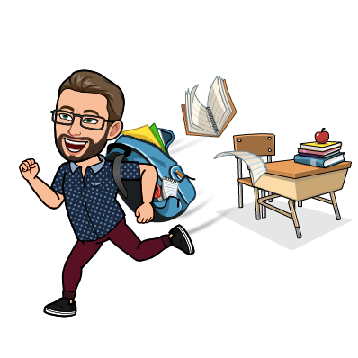
Leaving the Classroom

Looks like…
- Waiting until the teacher say “Have a wonderful day!” to pack up.
- Dropping off exit tickets

Sounds like…
- Quietly talking with friends or Mr. Simoneau.

Emergency Drills

Looks like…
- Following the directions of the teacher.
- Walking in a single file line out to the blacktop.
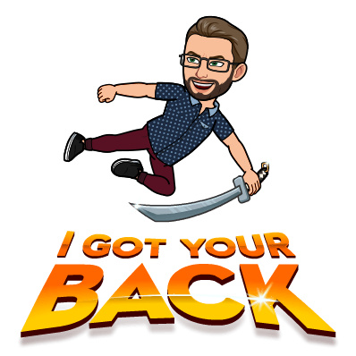
- Remaining in a single file on the blacktop.
- Walking in a single file line back to class.

Sounds like…
- Silently listening to the teacher during the whole drill.
- Silently walking to the blacktop.
- Silently remaining in line on the blacktop.
- Silently walking back to class.

Active Shooter Drills

Looks like…
- Watching the teacher for instructions.

Sounds like…
- Absolute Silence

