What is a Research Paper?

- A research paper has a topic that is narrow enough to research.

- It has a clear thesis statement that answers a question you came up with before you conducted research.

- It uses a variety of outside sources and includes direct quotations.

- It utilizes a clear organizational strategy.

- It uses formal language that is grammatically correct.

- It has a Works Cited page listing research sources.

Interests and Topics

An interest is a BROAD category with a lot of different areas of study

A Topic is a NARROW area of study where questions can be asked.

What are 3 things you enjoy?

- __________________________________
- __________________________________
- __________________________________

These are the 3 topics my table partner and I came up with:

- ______________________________________________________________

______________________________________________________________

- ______________________________________________________________
______________________________________________________________

- ______________________________________________________________
______________________________________________________________

The topic needs to been a part of the History of the United States from the 1600’s till 1910.

Picking a Topic

Historical sub-fields – History is a huge and broad umbrella that includes lots of sub-branches of history. Look at the list below and choose five to cross out (that you have NO interest in) and five to highlight (that you have a high interest in).

political history | social history | military history | economic history
religious history | cultural history | diplomatic history | environmental history
women’s history | demographic history | rural history | family history
ethnic history | labor history | urban history | history of education

Time Periods / Geographic Regions – the second thing that you have to do is to narrow down some geographic locations. Based on that, highlight one or two that you’d like to pursue.

Colonial Period | The American Revolution | The American Republic
Westward Expansion | America in the mid-1800’s | The Civil War and Reconstruction
The Industrial Revolution | Immigration | The Progressive Movement

Narrowing Down a Topic

Using the highlighted boxes (one from each box) on the previous page, come up with 8 board topic ideas that interest you.

- ____________________________________________________________________
____________________________________________________________________
- ____________________________________________________________________
____________________________________________________________________
- ____________________________________________________________________
____________________________________________________________________
- ____________________________________________________________________
____________________________________________________________________
- ____________________________________________________________________
____________________________________________________________________
- ____________________________________________________________________
____________________________________________________________________
- ____________________________________________________________________
____________________________________________________________________
- ____________________________________________________________________
____________________________________________________________________

Matriculation Madness!
Fill out the left column of the Bracket with your topics. Then pick the topic that is more interesting to you to move into the next round until you have a winner!

Narrowing Down a Topic

Thesis
Narrow Topic

Narrowing Down a Topic
Take your Broad Topic and ask yourself the following questions:
- Who?
  - Who is breaking the Barrier? Did they have Allies? Who were the enemies?

______________________________________________________________________________
______________________________________________________________________________
- What?
  - What is the Barrier? What kind of Barrier (physical, mental, cultural)?
______________________________________________________________________________
______________________________________________________________________________
- When?
  - When was the Barrier being broken? What was happening during this time?
______________________________________________________________________________
______________________________________________________________________________
- Where?
  - Where was the Barrier being broken? What was happening in the rest of the country?

______________________________________________________________________________
______________________________________________________________________________
- Why?
  - Why was there a Barrier in the first place? Why did it need to be broken?

______________________________________________________________________________
______________________________________________________________________________
- How?
  - How was the Barrier broken?

______________________________________________________________________________
______________________________________________________________________________

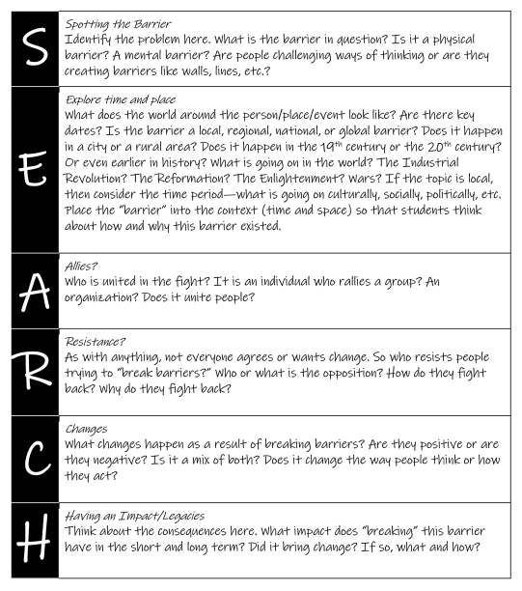

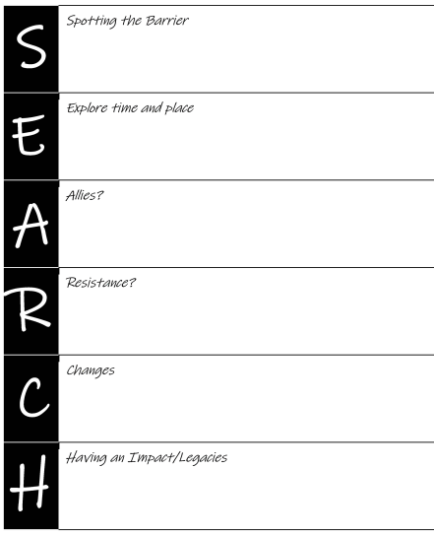

Creating a Thesis Statement

_________________________________________________________
^{(Your Topic)}

represents the theme of _____________________________________
^{(The theme)}

because it overcame the barrier of
_________________________________________________________
^{(the barrier)}

during ___________________________________________________
^{(the time)}

in _______________________________________________________
^{(the place)}

with the help of ____________________________________________
^{(Allies)}
while __________________________________ tried to stop them from
^{(Enemies)}

impacting the United States by ________________________________
^{(Changes)}

_________________________________________________________.

Creating Keywords for Research

Write down your topic or thesis statement:

______________________________________________________________________

______________________________________________________________________

______________________________________________________________________

______________________________________________________________________

Explore your topic by reading background materials (your textbook, online encyclopedias) or explore your own knowledge, speak with others, including your teacher. Fill in five questions.

What are the important questions you need answered? Ask: What if? Why? How? Should? So what?

- _______________________________________________________________

- _______________________________________________________________

- _______________________________________________________________

- _______________________________________________________________

- _______________________________________________________________

Circle the key or important words in your questions.

Creating Keywords for Research

Investigate with keywords

Use the important words circled in your questions to create your search terms:

___________________ | ___________________ | ___________________
___________________ | ___________________ | ___________________
___________________ | ___________________ | ___________________

Primary vs. Secondary Sources

Primary Sources:

People use original, first-hand accounts as building blocks to create stories from the past. These accounts are called primary sources, because they are the first evidence of something happening, or being thought or said.

Primary Sources are created at the time of an event, or very soon after something has happened. These sources are often rare or one-of-a-kind. However, some primary sources can also exist in many copies, if they were popular and widely available at the time that they were created.

All of the following can be primary sources:
- Diaries
- Letters
- Photographs
- Art
- Maps
- Video and film
- Sound recordings
- Interviews
- Newspapers
- Magazines
- Published first-hand accounts, or stories

Primary vs. Secondary Sources

Secondary Sources

Second-hand, published accounts are called secondary sources. They are called secondary sources because they are created after primary sources and they often use or talk about primary sources. Secondary sources can give additional opinions (sometimes called bias) on a past event or on a primary source. Secondary sources often have many copies, found in libraries, schools or homes.

All of the following can be secondary sources, if they tell of an event that happened a while ago:
- History textbooks
- Biographies
- Published stories
- Movies of historical events
- Art
- Music recordings

When Is a Primary Source Not a Primary Source?

You may have noticed that some things are on both the lists of primary and secondary sources. This isn't a mistake. The difference between a primary and secondary source is often determined by how they were originally created and how you use them.

Here's an example: a painting or a photograph is often considered a primary source, because paintings and photographs can illustrate past events as they happened and people as they were at a particular time. However, not all artworks and photographs are considered primary sources as they may have been created after the event or by someone who was not actually there.

Test your knowledge out. Are these primary or secondary sources? Circle the correct answer.
- A biography of Theodore Roosevelt written in 2001
Primary Secondary
- Photographs of Civil War soldiers in their camp
Primary Secondary

- Letters written by Abraham Lincoln
Primary Secondary

- A documentary on PBS about World War II
Primary Secondary

- A newspaper article from 1912 about the sinking of the Titanic
Primary Secondary

- A speech given by Martin Luther King
Primary Secondary

- A magazine article about the War of 1812
Primary Secondary

- An interview you had with a Vietnam War veteran
Primary Secondary

- Benjamin Franklin’s Autobiography
Primary Secondary

- A newspaper article from 1991 about the 50th anniversary of the Pearl Harbor attack
Primary Secondary

Please fill in the outline below:
Thesis:
_________________________________________________________________________________________________
__________________________________________________________________________________________________
Body Paragraph 1 - Context:
What is the Barrier: __________________________________________________________________________________

Give a brief description of the people and events that influenced your topic: ____________________________________
__________________________________________________________________________________________________
__________________________________________________________________________________________________
Body Paragraph 2 – Allies
Describe who is trying to break the barrier and who is helping them break the barrier: ______________________________________
____________________________________________________________________________________________________________
____________________________________________________________________________________________________________

Body Paragraph 3 – Resistance
Describe who is trying to keep the barrier up. How and why are they fighting back: ________________________________________
____________________________________________________________________________________________________________
____________________________________________________________________________________________________________
Conclusion –
Conclude how your topic impacted the United States and continues to impact the United States today: ________________________
____________________________________________________________________________________________________________
____________________________________________________________________________________________________________

Web Searching – Choose three of the links below to explore.
Our Documents - http://www.ourdocuments.gov/index.php?flash=true&
Look at the 100 most important documents in US history.
Choose three that you think are interesting and note WHY you are interested in these documents

Document…. | This is interesting because….

Library of Congress - http://www.loc.gov/teachers/classroommaterials/primarysourcesets/
Click on the link above and choose two set of primary sources
Primary Source Set…. | This caught my attention…

National Historic Landmarks - http://www.nps.gov/nhl/
Sometimes a place can inspire an idea….the National Parks Service protects historic places across the United
States
Ideas…..

PBS History - http://www.pbs.org/topics/history/
On the menu bar across the top, choose the “topics” and choose some categories that interest you. Note your pathways and ideas in the boxes below.

Ideas…..

Library of Congress Timeline –
http://www.loc.gov/teachers/classroommaterials/presentationsandactivities/presentations/timeline/index.html
If you like to look at history chronologically…..try this
Ideas….

3 Reads Protocol

First Read:  Comprehension | INSERT QUOTE OR  EXCERPT FROM LARGER TEXT  -------------  When facilitating a close-reading protocol, it’s important to focus the reading on a smaller chunk of text rather than long excerpts. Make sure to be purposeful in selecting a quote or excerpt when using this protocol. See examples attached on the  next page. | Second Read:  Analysis
Annotate for the following:  - What does the text say?  - What is the main idea of the text?  - What is happening in the text?  - What do the key terms in the text mean?  - What kind of text is it? |  | Annotate for the following:  - What does the text mean?  - Which historical thinking skills can be used to analyze this text?
Third Read:
Connecting to Content
Reflect on the following:

- So what?
- How does this text connect to the larger narrative or story of American history?
- How does this text connect to the historical context?
- What can we learn from this text about American history?

Website Research Notes
Copy & Paste Web Address | Create citation in MLA format using Purdue OWL website to help
Copy & Paste Text Directly from Source | Paraphrase information in your own words.

Create citation in MLA format from Purdue OWL
and write here.
PAGE NUMBER | Paraphrase information in your own words.  If using direct quote, put in quotation marks.
 | __________________________________________________________________________________________________________________________________________________________________________________________________________________________________________________________________________________________________________________________________________________________________________________________________________________
 | __________________________________________________________________________________________________________________________________________________________________________________________________________________________________________________________________________________________________________________________________________________________________________________________________________________
 | __________________________________________________________________________________________________________________________________________________________________________________________________________________________________________________________________________________________________________________________________________________________________________________________________________________
 | __________________________________________________________________________________________________________________________________________________________________________________________________________________________________________________________________________________________________________________________________________________________________________________________________________________

